SIMATS ENGINEERING (SAVEETHA SCHOOL OF ENGINEERING)
Department of Computer Science and Engineering
ASSESSMENT TOOL 1 – RAG-BASED MINI ASSIGNMENT (DOCUMENT QA / AI AGENT
DEMO)

Course Code: | CSA65 | Course Title: | Generative AI and Large  Language Models
CO Assessed: | CO3 – Precision (BL2, BL3) | Assessment: | Assessment Tool 2 –  RAG-based Mini Assignment  (Document QA / AI Agent  Demo)
Weightage: | 20% of CIA | Total Marks: | 2 * 50 = 100 (1 Question1)
CO3  Statement: | Develop intelligent applications using Retrieval-Augmented Generation (RAG), vector databases, and introductory AI agent concepts.(BL3, BL4)
Student Name: | C. Anu Keerthana | Reg. No.: | 192472057
Section / Batch: |  | Date:

Instructions to Students
● Answer 2 questions. Each question carries 50 marks.Total: 100 Marks.
· Implement the solution using Python.
· Use an appropriate LLM such as OpenAI, Gemini, or Hugging Face.
· Use embeddings and semantic search where applicable.
· Use FAISS or ChromaDB as the vector database for RAG tasks.
· Demonstrate the complete pipeline:
Document → Chunking → Embedding → Retrieval → Generation
· Demonstrate the system with multiple queries.
· Handle irrelevant, incomplete, or unsupported queries appropriately.
· Display retrieved context/source wherever applicable.
· Explain the system architecture.
· Provide a working end-to-end demonstration.

Code of Conduct
I ____________C.Anu Keerthana(192472057)______________ (Name / Reg No) certify that this submission is my original work and that I have adhered to the guidelines specified for this assessment. I understand that any violation of academic integrity rules will result in disciplinary action. Signature of the Student: ____C. Anu Keerthana_____________________

SECTION A – RAG-BASED MINI ASSIGNMENT (DOCUMENT QA / AI AGENT DEMO)

- Chunk Size Comparison in RAG: Experiment with small, medium, and large chunk sizes. Compare retrieval and answer quality and explain the best choice.
- University Regulations RAG Assistant: Develop a RAG assistant using university regulations. Answer questions about examinations, attendance, internal assessment, progression, and graduation requirements.

QUESTION 14 – Chunk Size Comparison in RAG
1. Title
Chunk Size Comparison in Retrieval-Augmented Generation (RAG)
2. Aim

To implement a Retrieval-Augmented Generation system and experimentally compare small, medium, and large chunk sizes to determine their effect on retrieval relevance and generated answer quality.

3. Objectives
- Load a document as the knowledge source.
- Divide the document into different chunk sizes.
- Generate embeddings for each chunk.
- Store the embeddings in FAISS.
- Perform semantic retrieval for user queries.
- Generate answers using Gemini.
- Compare retrieval and answer quality for different chunk sizes.
- Identify the best chunk size based on experimental results.
- Handle irrelevant and unsupported queries.

4. Introduction
Retrieval-Augmented Generation (RAG) is a technique that combines information retrieval with Large Language Models (LLMs). Instead of depending only on the knowledge stored inside an LLM, RAG retrieves relevant information from an external document and provides it as context to the LLM.
The basic RAG pipeline is:
Document → Chunking → Embedding → Retrieval → Generation
Chunk size is an important parameter because it determines how much information is stored in each vector. Very small chunks may provide highly precise information but can lose important context. Very large chunks preserve more context but may contain irrelevant information.
Therefore, this experiment compares three chunk configurations.

5. Chunk Configurations
Configuration | Chunk Size | Overlap
Small | 120 words | 20 words
Medium | 250 words | 40 words
Large | 500 words | 80 words

Small chunks
Small chunks contain limited information.

Advantages:
- High retrieval precision
- Less irrelevant information
- Useful for direct factual questions
Disadvantages:
- May lose surrounding context
- Related statements may be placed in different chunks
Medium chunks
Medium chunks provide a balance between context and precision.
Advantages:
- Good contextual information
- Good retrieval precision
- Suitable for most questions
Disadvantages:
- May contain some unnecessary information
Large chunks
Large chunks contain more surrounding information.
Advantages:
- Better context preservation
- Useful for questions requiring multiple related statements
Disadvantages:
- More irrelevant information
- Lower retrieval precision in some cases
- Larger LLM context usage

6. System Architecture

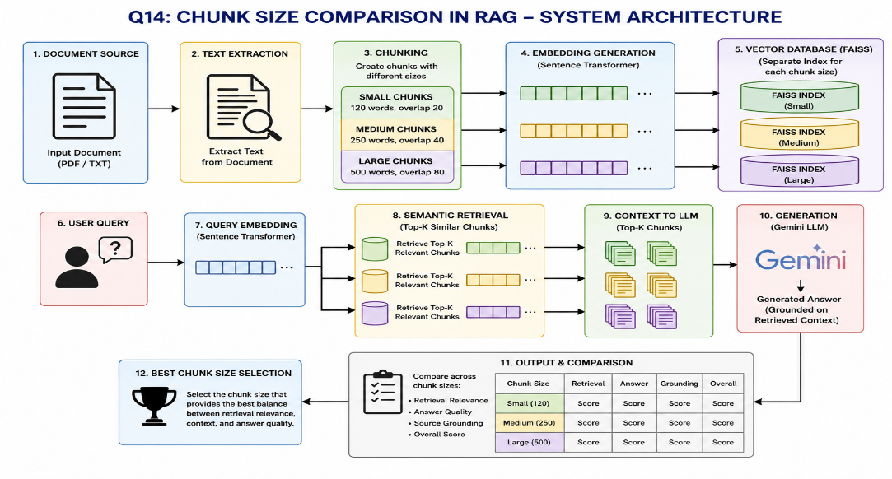

7. Technologies Used

Technology | Purpose
Python | Implementation
Gemini | Answer generation
Sentence Transformers | Text embeddings
FAISS | Vector similarity search
PyPDF | PDF processing
NumPy | Numerical operations

Python Implementation

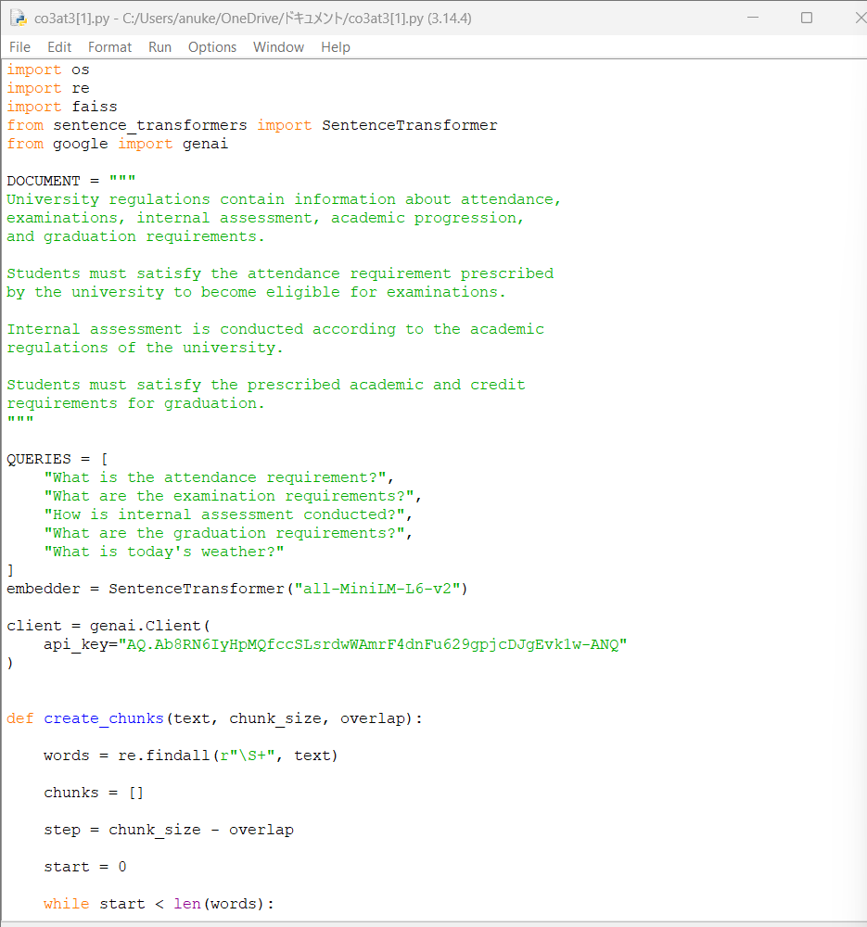

Expected Output

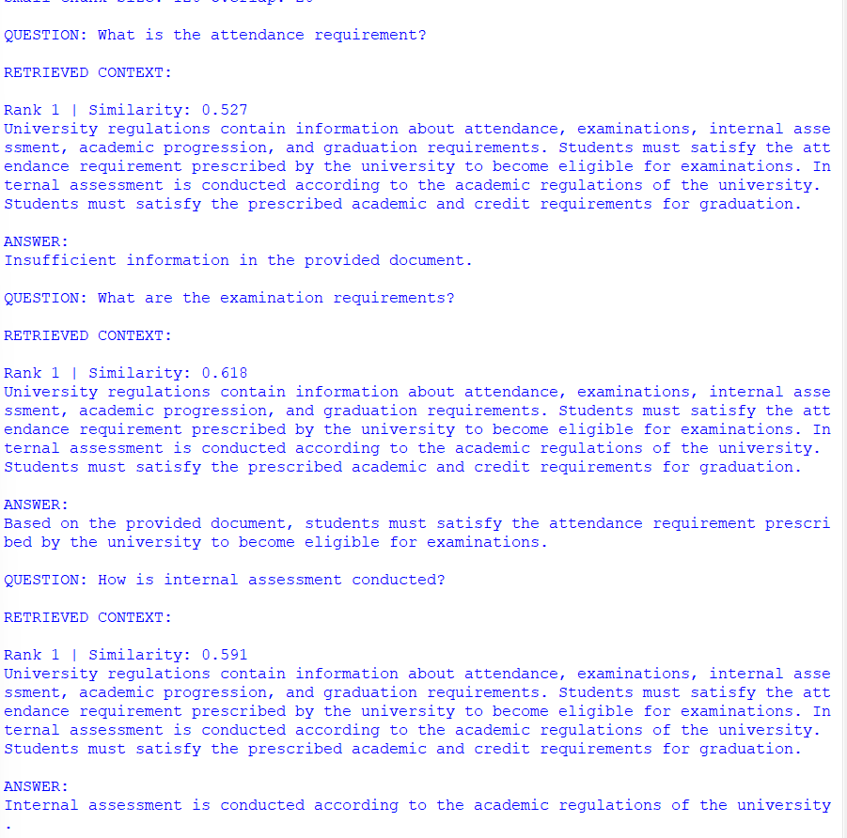

Result Analysis
A typical observation is:
Chunk Size | Retrieval Precision | Context | Noise | Answer Quality
Small | High | Low | Low | Good
Medium | High | Good | Moderate | Very Good
Large | Medium | High | High | Good

Best Choice
Medium-sized chunks are expected to be the best practical choice.
The medium configuration provides enough context to answer questions while avoiding much of the unnecessary information introduced by large chunks.

QUESTION 17 – UNIVERSITY REGULATIONS RAG ASSISTANT

1. Title
University Regulations RAG Assistant

2. Aim
To develop a RAG-based university regulations assistant that provides accurate, source-grounded answers to student questions related to examinations, attendance, internal assessment, academic progression, and graduation requirements.

3. Objectives
- Load the university regulations PDF.
- Extract text from the document.
- Divide the document into chunks.
- Generate embeddings.
- Store embeddings in FAISS.
- Perform semantic retrieval.
- Provide retrieved context to Gemini.
- Generate a grounded answer.
- Display the relevant source/page.
- Handle unsupported and irrelevant queries.

4. Input Document

Create the following folder structure:
University_RAG
│
├── data
│ └── university_regulations.pdf
│
└── university_rag.py

It contain sections such as:
Attendance Regulations
Examination Regulations
Internal Assessment
Academic Progression
Credit Requirements
Graduation Requirements

5. Complete RAG Pipeline
University Regulations PDF
↓
Text Extraction
↓
Chunking
↓
Embedding
↓
FAISS
↓
User Query
↓
Query Embedding
↓
Semantic Similarity Search
↓
Top-K Relevant Chunks
↓
Gemini LLM
↓
Generated Answer
↓
Source / Page

System Architecture

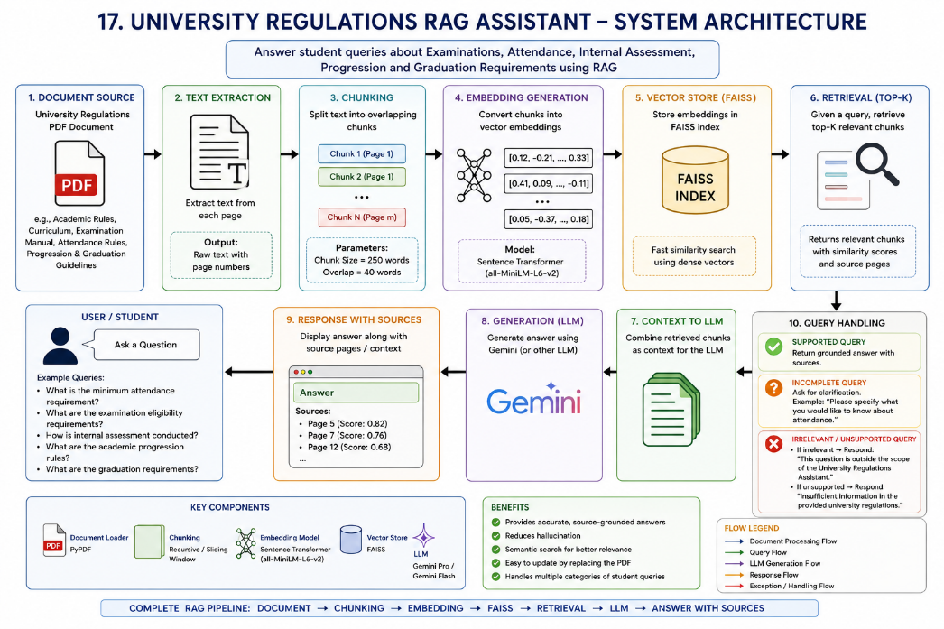

6. Python Code

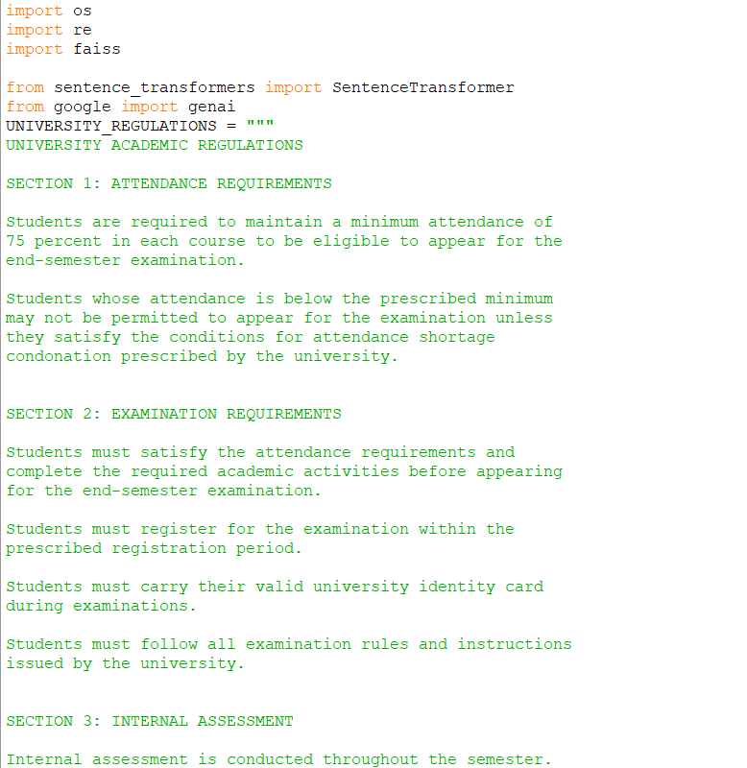

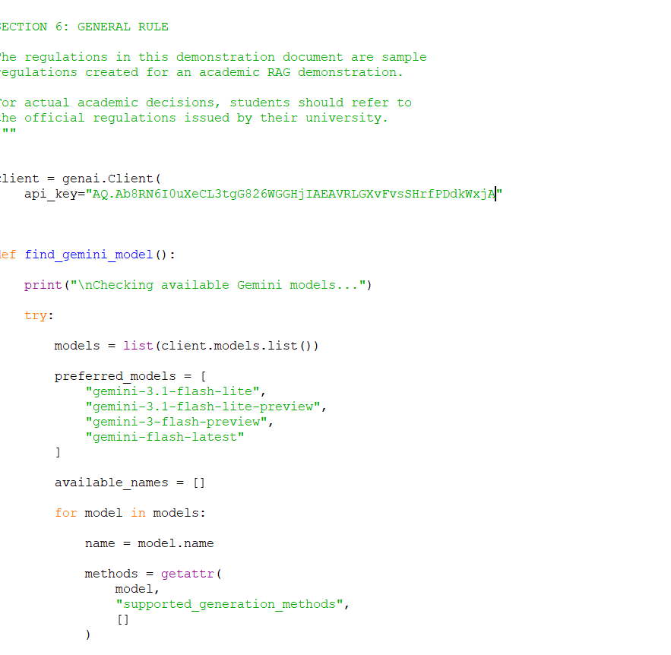

Expected Results

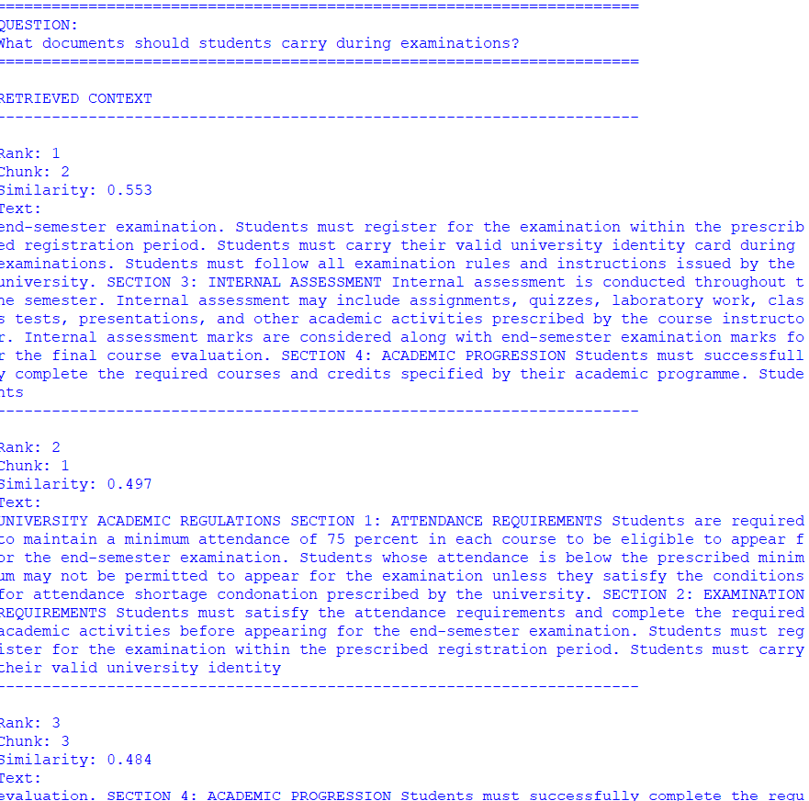

Query | Retrieval | Generation | Source
Examination | Relevant | Grounded answer | Page shown
Attendance | Relevant | Grounded answer | Page shown
Internal Assessment | Relevant | Grounded answer | Page shown
Progression | Relevant | Grounded answer | Page shown
Graduation | Relevant | Grounded answer | Page shown
Irrelevant query | No useful regulation | Out-of-scope response | Not applicable
Unsupported query | Insufficient evidence | No hallucination | Shown if retrieved

Advantages
- Uses official university documents as the knowledge source.
- Provides semantic rather than simple keyword search.
- Reduces hallucination.
- Shows supporting source pages.
- Easy to update by replacing the PDF.
- Can answer multiple categories of student questions.
- Uses an LLM for natural-language responses.
- FAISS provides efficient vector similarity search.

Limitations
- Quality depends on the quality of the university regulations PDF.
- Scanned PDFs may require OCR.
- Incorrect or outdated regulations can produce incorrect answers.
- Embedding quality affects retrieval.
- Poor chunk sizes can reduce retrieval performance.
- LLM responses still require verification for important academic decisions.
- API access may be required for Gemini.

Final Conclusion
The implemented system demonstrates a complete Retrieval-Augmented Generation pipeline:
Document → Chunking → Embedding → Retrieval → Generation

RUBRICS FOR CALCULATION

Criteria | Weighta ge | Level 4 –  Exemplary | Level 3 –  Proficient | Level 2 –  Developing | Level 1 –  Beginning
Pipeline  Functionality | 30% | Correct RAG pipeline — embeddings, retrieval and generation all function coherently | Pipeline mostly correct with minor gaps | Pipeline only partially functional | Pipeline non-functional or conceptually flawed
Answer Relevance &  Groundedness | 25% | Retrieves relevant context and generates accurate, grounded answers | Mostly  relevant/accurate answers | Inconsistent relevance or accuracy | Answers largely irrelevant or hallucinated
Query  Robustness | 20% | Robust handling of  varied queries and documents | Handles most queries well | Handles only simple queries | Fails on basic queries
End-to-End Demo | 15% | Smooth, well-demonstrated end-to-end system | Demo mostly smooth, minor hiccups | Demo has noticeable issues | Demo fails or is not ready
Architecture Explanation | 10% | Clear architecture diagram and explanation of design decisions | Adequate explanation of design | Minimal explanation of design | No explanation of design provided

Marks Evaluation:
Questio n No. | Pipeline  Functionality(30  %) | Answer Relevance &  Groundedness  (25%) | Query  Robustness(  20%) | End-to-End Demo(15%) | Architecture  Explanation (10%) | Total  Marks  (100)
Q1
Q2
 |  |  |  | Overall Total (100)

